Introducing BeSiVa: An Algorithmic Approach Applied to Predicting Voter Turnout
By Benjamin Rogers
The University of Kansas
September 2016
'We take seriously indications or indicators not taken further down the inference trail; we take them seriously but with a pinch of salt labelled “indication only”' (Mosteller and Tukey 1977, 40)

Introduction
This paper introduces a new algorithm and a reconsideration of an old way of assessing model quality, focusing on prediction and the choice to vote. With the BeSiVa algorithm (short for Best Subset in Validation algorithm), prediction is reconsidered by using it as a more rigorous means of determining theoretical relevance than statistical significance. It is too often assumed that if an independent variable is statistically significant, even if its effect is beyond marginal, then it will be useful in predicting un-modeled observations of the dependent variable, an approach which Schrodt labels 'pre-scientific' (2014). Schrodt also points to Achen, who states that parsimony is essential to the point where any model with more than 3 variables is poorly specified. In addition, Achen suggests that logistic regression is heavily overused in modeling phenomena, and that a further consideration of the regression techniques are necessary for appropriate modeling (2002). This paper considers questions raised by Schrodt and Achen and introduces an algorithm that answers them by concentrating on models and variables' abilities to make predictions. Rigorously testing theoretical predictions through a predictive modeling approach, selecting variables to add rather than adding everything indiscriminately and determining what must be added, represents the major contribution of this paper.
The predictive approach of this paper is concentrated in the BeSiVa algorithm. The BeSiVa algorithm can compare any independent variables provided to it while it attempts to predict the dependent variable. The algorithm will suggest a single model, but through repeated testing its findings can also be used to create extensively predictive models. While any variables may be provided to the algorithm, the variables that it recommends may be compared against highly theoretically specified models from multiple perspectives. This is useful if the variables provided were theoretically specified beforehand, allowing BeSiVa to compare not only independent variables, but also the theory that suggested their addition.
BeSiVa can take theoretically specified explanations, operationalized by a collection of independent variables, and determine which theoretical explanation or explanations are best at predicting new values of the dependent variable. Unlike in purely predictive analyses, however, BeSiVa is used on a collection of theoretically specified variables, allowing for the determination of their relevance in predicting whether individuals vote based on reasons suggested by theory. The algorithm's determination that education and party identification are key in predicting whether an individual turns out to vote, as well as age and sex are hardly surprising. Its determination of these variables as the most useful in predicting turnout, however, suggests what elements of the theory are most useful in determining whether a person votes or not. Indeed they are preferable to other elements of mobilization and sociological theories of turnout, demonstrating the utility of a set of theoretical approaches according to a predictive criterion. In addition to ushering in a more scientific verification of theory, as Achen suggests, the paper also shows the continued utility of logistic regression, as well as a more rigorous verification of the need for parsimony.

A Briefer History of the Choice to Vote
The choice to vote has a lengthy history in political science, and researchers have suggested many causal mechanisms that drive turnout, making it an ideal subject for a predictive algorithm. Scholars have debated why people turned out to vote for over fifty years, leading to many different theoretical models. Their contributions, however, tend towards adding variables and explanations rather than removing them, making it difficult to determine the relative utility of variables and explanations. This aggregation of variables and models led to an expansion of explanations and mechanisms that often fail to do a good job of making predictions when it is considered.
The Michigan school originated the study of turnout as well as vote choice, and their focus on a single variable led to a starting point that was better at making predictions than many later causal explanations.. Although it focused primarily on the choice voters made once they turned out, the Michigan school also considered the role of party identification in deciding to turn out, providing a starting point for researchers. In describing their mechanism for turnout, Campbell et al. admitted to a potential lack of primacy of their causal reasoning, suggesting that no single datum could explain all aspects of the choice to vote (1960, Dalton and Wattenberg 1993). This admission gave Wolfinger and Rosenstone the chance to determine what other elements of a citizen's life could also drive turnout (1980), exemplifying the sociological approach to voting. Wolfinger and Rosenstone compared demographic trends via census data, suggesting that contrary to the class based suggestions of political theorists such as Schattschneider (1975), the key resources to turning out were based in experience and knowledge.
Wolfinger and Rosenstone's key finding related to comparing the importance of demographic trends and finding which ones mattered. For instance, education mattered dramatically, imparting skills and experience necessary to capably maneuver problems of participation. Age could also provide experience to maneuver through government separately from education. Whether someone was married mattered as well, providing a strong interpersonal pressure to vote (Wolfinger and Rosenstone 1980). These drivers of whether or not an individual turned out mattered more than class-based approaches to participating, which were not found to be as essential. Although Wolfinger and Rosenstone were able to find roles for demographic predictors of turnout, the limitations of their data made comparing and accumulating understanding of turnout difficult. Attempting to overcome the difficulty of using census data, later authors such as Teixeira gathered additional information, but the models in these works became excessively large due to the literature's demands.
Attempting to determine reasons for the aggregate decline in turnout, Teixeira focused on individual turnout, and managed to overcome limitations that hampered Wolfinger and Rosenstone. In doing so, Teixeira created an expansive theoretical picture which illustrated a new problem plaguing the turnout literature. Teixeira included many demographic variables, but expressed skepticism of their importance in the theory, despite keeping them as controls (1987). This is reasonable given the later findings of Verba et al. who suggested that at least one of the predictors was unimportant in questions of turnout (1993). Teixeira's work, however, fell victim to a requirement of the literature, whose discussion of an excess of causes led to models with massive collections of variables. But what else could be done? The specification of such models and findings of significance for these variables in prior work indicated a need for their inclusion. Even as models grew to sizes that made findings difficult to understand, the list of theoretical causes continued to grow, decreasing the likelihood of paring down theories of turnout to a manageable set of explanations.
In addition to previous causes, further theorizing continued to expand the literature, making interpretable and parsimonious models even more unlikely. As an example, Rosenstone and Hansen suggested a new causal mechanism to explain turnout through the mobilization model. In the mobilization model, pressures and incentives from organizations and politically motivated actors in someone's social network led them to participate (Rosenstone and Hansen 2003). Moving beyond the concerns of demographically oriented studies, Rosenstone and Hansen contributed a new causal mechanism, avoiding the pitfalls of literature that concentrated on increasingly subset demographic groups. By adding an additional causal mechanism, however, the expansion of conflicting theories of turnout are emblematic of a greater problem in the literature.
In considering these differing conceptions of the choice to vote, the problem of the literature is that it is difficult to find a way to determine the correctness or utility of different theories, determining which conceptions of turnout are most useful in predicting if an individual will vote. This is not reflective of the work of theorists, whose contributions are invaluable, but the means by which these theories are tested. One typical critique made of the social sciences in general, revolves around why multiple phenomena cannot contribute to a topic of interest in equal measure. While this should be eschewed due to the fact that it adds little to our understanding, the problem of figuring out which predictors of a phenomenon are most useful remains unconsidered.
While the literature is capable of providing many theoretical explanations, the chance to create a competition between theories remains untaken. Too often, the literature focuses on adding, rather than subtracting elements of models, until massive lists of variables are necessary to suitably control for the collection of theoretical explanations. This approach to determining veracity falls decisively in opposition to the rule of three espoused by Achen (2002). Achen argued that treating subgroups within enormous models as something that can be controlled for through dummy variables is incorrect, culminating in the Rule of three. The rule of three states that any model with more than three independent variables is meaningless due to poor specification. But the main thrust of the literature does not appear to be to answer Achen, either by arguing against his rule, or by trying to work within such a framework, but to ignore it completely (Schrodt 2014), which only leads to larger models and greater problems with 'garbage can' approaches.
While a few efforts, such as Verba et al. (1993) have been made to cut down on the number of variables that explain political participation, the main thrust of the literature is to continue increasing the number of causes. Researchers focus on building, rather than sculpting the collection of explanations that should be used to understand turnout. While multiple causes may drive the choice to vote, and may even simultaneously explain parts of the variation in whether someone decides to turn out, an alternative approach, such as the BeSiVa algorithm should allow for consideration of the utility of alternating causes. Instead of adding to the potential list of causes, BeSiVa, like other predictive approaches, compares the variables that are provided to it, using the information to create a model that makes the best prediction of turnout. The BeSiVa algorithm then, allows for the consideration of a collection of causes in a manner that will compare and pare down the list of variables and causal mechanisms, rather than add to it.

What is the BeSiVa Algorithm?
The BeSiVa algorithm was designed to take a collection of independent variables, and determine which were most useful in predicting a specific dependent variable. In this case, that dependent variable is whether or not someone chose to vote, but the algorithm can currently apply to any binary dichotomous variable. The algorithm will take a prespecified dataset, dependent variable and independent variables provided to it, and attempt to make the best prediction of the dependent variable from the independent variables. In doing so, it uses a predictive criterion to decide which variables lead to the best prediction of the choice to vote, paring down the number and selection of theoretical causes specified by the literature.
[Figure 1 about here.]
BeSiVa's first step involves dividing the data into two subsets, as illustrated in figure 1. One subset, referred to as the training set, will be used for the estimation of models, while the other, the test set, will be kept separate from estimation to figure out how well the models predict the dependent variable (Kuhn and Johnson 2013). The data is divided to prevent overfitting, a situation where a model makes excellent predictions on the data provided to it, and is incapable of predicting any data apart from that which was used to estimate its model (Clark 2004, Kuhn and Johnson 2013). There is no optimal ratio for the dividing the data between test and training sets, but the default ratio of 20% of observations for test to 80% for training was recommended (Kuhn and Johnson 2013), and stayed constant throughout the study. Once the data has been divided to prevent overfitting, the algorithm makes a series of models from the training set, with the ultimate goal of determining which model makes the best prediction of the dependent variable.
Having divided the data, the algorithm then conducts a series of regressions using the training set. The models it creates initially include a single variable each, and BeSiVa makes a model for each independent variable that is provided. These models are created using logistic regression, hence the need for a dichotomous dependent variable. The model that makes the best prediction will be saved, and the variables that were used to create it will be included in all future iterations, but in the first iteration, each model contains one variable. Regardless of how many variables are ultimately included, however, the models generated using the training set may now be tested using the data from the test set.
Once BeSiVa creates its set of models, it has to test them to determine which best predicts the dependent variable. Having set aside the test set until this point, the algorithm now uses the models created from each variable to predict the dependent variable in the test set. Logistic regression's predictions are a series of probabilities (Rabe-Hesketh and Skrondal 2012), and BeSiVa classifies the most likely value of the test set's dependent variables using the model's predicted probabilities. It uses a cutoff, rather than running through a binomial trial, with probabilities above 50% predicted to be 1, and anything 50% or below predicted as 0. This approach to classification avoids the randomness that a binomial trial would entail, and it is consistent with a preference for overall accuracy (Kuhn and Johnson 2013). Once BeSiVa has made a prediction on each observation in the test set, the predictions may be compared to the actual values of the dependent variable, assessing the quality of the models BeSiVa creates.
Now that each model has a set of predictions created for the test set, and the predictions have been scaled to the dependent variable, the algorithm must decide which of the models is most capable of making predictions. To make this decision, BeSiVa calculates a Percent Correctly Predicted (PCP) for each model. Sometimes referred to as the overall error rate (Kuhn and Johnson 2013), the PCP is the ratio of correct predictions, such as predicting a 1 when the measured value in the test set is a 1, to the total number of observations in the test set. The algorithm compares the PCPs from each model, and the variable or variables from the model with the largest PCP are saved. Having used PCPs to compare models, BeSiVa completes its first iteration, saving the largest PCP and the model that generated it.
Once it considers every independent variable, and determines which model creates the largest PCP, BeSiVa returns to the start of its process. When it returns, however, it takes the variable from the model with the largest PCP with it. In the first iteration, this is a single variable, which is kept in all models in the next iteration; the second iteration yields a two variable model, and another variable is added for each iteration of the algorithm. This is true in all cases, unless a tie occurs, defined as when two models yield the same PCP. If two models yield the same PCP, BeSiVa stops at the iteration before the tie. It still returns the independent variables and PCP, just from the model with the highest PCP before the tie. Regardless of whether there is a tie, or BeSiVa reaches the maximum number of iterations specified by the user, it includes the independent variables for the model with the largest PCP, as well as the PCP. In this way, BeSiVa allows for a consideration of how capable the model it creates is at predicting the dependent variable.

The Data
In order to understand what drove voter turnout, the American National Election Study, or ANES, was selected as a source for data. The ANES serves as a logical choice to study turnout, especially at the level of individual voters. The study's time series cumulative data file allows for consideration of differing drivers behind the choice to vote ranging back to 1948. In addition, the data allows for a consideration of a large collection of potential drivers of turnout in a manner that lets BeSiVa make a comparison of each predictor's relevance. Once any category deemed missing was recoded appropriately, the question of what selection of the data should be used. Due to its relative recency, and the availability of a wide selection of variables appropriate to the theories of turnout (as compared to earlier elections, such as 1948 or 1952), the 2000 election data was selected for analysis.

The Dependent Variable
Given the focus on the choice to vote, the operationalization of the dependent variable was relatively straightforward. In one of their survey responses, the ANES asked whether an individual voted in a given election, which was used as a proxy for their behavior. There is an understanding, however, that an individual might decide not to vote, but when queried, would specify that they did due to response bias, (Belli, Traugott, and Beckmann 2001, Tourangeau and Yan 2007). Despite this potential drawback of using survey responses rather than voting records, the risk of response bias is accepted as a limitation of the design, and is irrelevant to the algorithm's ability to predict. Given that the main point of using turnout is to test the algorithm, the risk of response bias in the dependent variable is secondary to the utility of the predictions created. Missing data were properly recoded, and the survey responses were changed into a numeric dichotomous variable with 1 for yes and 0 for no, but no other changes were made to the dependent variable. Having selected turnout as a dependent variable, the algorithm only needed a series of independent variables to create a predictive model of the choice to vote.

Independent Variables
Having determined that self-reported choice to vote would serve as the dependent variable, a selection of independent variables were provided to BeSiVa for its consideration. The first variable that was included for consideration was an individual's party identification. Dating back to the Michigan School, party identification may affect an individual's likelihood to turn out due to interest and attachment to the outcome (Campbell et al. 1960, Dalton and Wattenberg 1993). In the ANES data, party identification was measured as a 7 item categorical variable, ranging from strong partisan, weak partisan, independent but leaning towards a party, and truly independent. For the algorithm's consideration, and due to the fact that party strength, rather than party, is theorized to lead a person to turn out to vote, however, party identification was recoded as a numeric variable capturing the strength of an individual's identification. This operationalization of the strength of party ID ranged from 0 for independents to 3 for strong partisans of either party. Thus, party identification, long associated with turnout, was included in a manner consistent with the component expected to correspond to turnout behavior, along with other variables suggested by the literature.
In addition to party identification, a collection of variables based off the opinions of sociological theorists were included, starting with education. Operationalized based on if someone had achieved levels of schooling, education is theorized to increase how much individuals enjoy politics (Wolfinger and Rosenstone 1980). It has also been suggested that education aids individuals in maneuvering the mechanics of voting (Teixeira 1987), or enables the individual to better parse political information (Rosenstone and Hansen 1993). Education was included in the ANES as a 6 category factor variable, ranging from finishing grade school to advanced degrees, with values in between to capture whether someone had finished high school or a bachelor's degree. The variable, however, was taken and transformed into a numeric variable, one which captured a person's level of education as a continuous predictor. This operationalization of education was relatively straightforward, and its multiple backing theories and relative agreement made it a necessary addition to the list of variables to consider.
Education was one example of a variable with multiple proposed causal mechanisms related to turnout behavior, as was age. Age was hypothesized to affect vote choice as a proxy for political experience, which could substitute for education (Wolfinger and Rosenstone 1980). It was also a potential driver due to the existence of shared generational experience or differing drives at stages of the life cycle (Rosenstone and Hansen 1993). Age was asked about on the ANES as a numeric variable, and was provided to the algorithm in its unrecoded form, as well as an age squared term, to capture possible non-linearities. This meant that age was included based on how old the individual was at the time of the survey, a continuous predictor of an individual's experience.
In addition to variables that indicated a person's cognitive resources, such as age and education, the literature described individuals' connections to media as a possible determinant of turnout behavior. Teixeira suggested that links to the media, operationalized based on how often someone read the newspaper, allowed voters to be more engaged, giving each election a sense of meaning and making an individual more likely to turn out (1987). The ANES inquired about newspaper reading directly, and the number of days per week an individual read the paper was provided to the algorithm as a possible predictor of turnout. The number of days reading the paper was included as a numeric predictor, and ranged from none to seven. With this way of determining how politically connected through the media an individual was, the algorithm could capture these links' overall relevance.
Due to the fact that it has been defined in multiple ways, political efficacy was challenging to include for the algorithm's consideration. Political efficacy, based in the notion that an individual believes they influence the outcome, has been theorized to increase the likelihood of voting due to the increased sense of accomplishment that such a feeling provides (Teixeira 1987). It can also make things easier for a potential voter, with a sense of personal competence makes someone feel more comfortable participating in politics overall (Rosenstone and Hansen 1993). Political efficacy is operationalized using this sense of influence over the outcome, helping to determine its role in the prediction of whether a person votes by including it for the algorithm's consideration.
Despite the fact that it has been suggested as a key driver in some corners of the literature, the role of income in predicting turnout has been disputed. While such a resource may make individuals more capable of participating in politics (Schattschneider 1975), Wolfinger and Rosenstone suggested that income only mattered to the point of comfort (1980). Teixeira, by comparison, suggested that greater incomes were capable of easing the challenge of voting as a component of socioeconomic status (1987), while Rosenstone and Hansen suggested that it would make participation more likely, due to an increased likelihood of sharing social circles with the political class (1993). To try and capture income's potential role, the income categories of the ANES were recoded as a numeric predictor, treating the different selections of the respondent's income quantile as a driver of political participation. Once it had been recoded, its ability to capture whether income could potentially predict turnout made it an invaluable addition to the list of variables for consideration.
The use of race as a predictor of whether someone turns out to vote has been disputed (Verba et al. 1993) as are individuals' sex and the region in which someone lives (Teixeira 1987). Their roles as operationalizations of historical privilege and political culture (Wolfinger and Rosenstone 1980, Teixeira 1987), however, and their disputed status meant that these demographic predictors should be included in the list of variables to consider. Race was recoded from a 7 point scale based on a self identification of ethnicity, which was changed to a dichotomous variable based on whether an individual was in the minority. Region was a 4-fold classification based on whether someone lived in the northeast, north central, south, or west of the United States. Similarly, sex was included for consideration as a binary dichotomous categorical variable. Given their disputed status, these variables are ideal for a predictive algorithm, allowing for their consideration in a more systemic fashion.
Unlike the disputed status of race and other demographic predictors, marital status is a relatively uncontroversial addition to the list of independent variables for the algorithm to consider. Being married lessens the costs on an individual to go out and vote while providing a separate incentive to do so due to an additional stake in the election (Teixeira 1987). While not directly mentioned, marital status makes intuitive sense from a mobilization perspective as well. A second person increases the likelihood of being embedded in social networks, increasing the likelihood of direct and indirect mobilization (Rosenstone and Hansen 1993). To capture marital status, its effect on networks, and where it put someone, an individual's marital history was considered. Although it was asked about in the ANES from the perspective of whether someone had been married, the variable was dichotomized to focus on whether or not someone was divorced, as a way of separating out those who had been married and separated from those who had not. With this operationalization of an individual's overall marital status, BeSiVa could determine its relationship to turnout due to the inclusion of a variable operationalizing it.
Due to their consideration as potential operationalizations of mobilization, a collection of variables were included to determine whether individuals voted due to political contact. Multiple variables to determine whether an individual had been contacted by a party or some other organization were included for the algorithm's consideration, as well as their employment status, a key predictor of being at the center of a network of potential mobilizing agents (Rosenstone and Hansen 1993). The ANES captured these responses through a series of dichotomous questions, asking whether an individual had been contacted by the Democratic or Republican parties, any party, or by another political organization. These variables were included for the algorithm's consideration as a means of capturing whether someone had been directly mobilized.
Direct mobilization is a key means of determining participation in the mobilization model of political participation, but it remains half of the main drivers of mobilization theory, and merited inclusion. This was done in the form of an individual's connection to networks through religious participation, asking wheter they attended church or not. Church attendance was used to further capture the potential role of such a network, which was asked as a 5-item question based on how often someone went to church over the course of a year. This was recoded, however, into a dichotomous response to determine whether someone attended church or not. With this means of capturing whether an individual was connected to a greater network, a selection of variables most relevant to understanding whether an individual chose to vote or not could be considered by the algorithm.

Methods
Once the variables were recoded into more theoretically appropriate forms, they were provided to the algorithm, which went to work determining which independent variables best predicted turnout behavior. Instead of running the algorithm once, however, the algorithm was run on the same data 100 times, randomly separating the data into different training and test sets each time. The training and test sets were varied by the use of different random seeds, guaranteeing a different division of data each time while also making it possible to recreate results as needed. The data, independent variables, and dependent variables were always the same, as were the arguments provided to the algorithm. These arguments specified five iterations, meaning that the maximum number of variables in any single model the algorithm created was 5. It also specified a threshold of 0.1%, meaning that any variable that could be added to the model would need to make the PCP improve by at least one tenth of one percent, or the algorithm would stop and return its results. The algorithm was run on the data, and the results of the PCP as well as the independent variables were saved, analyzed, and compared against theoretically specified models.
[Figure 2 about here]
From the 100 runs of the algorithm, two of the major outputs related to the final model that BeSiVa recommended, its PCP, and the independent variables that it specified were saved. The PCPs for each of the runs may be seen in figure 2, displayed in the histogram and kernel density plot. This shows the distribution of the PCPs, and notably the mean PCP of 70.5%. There is very little skew, with the median at 70.1%, and there is a relatively tight concentration around the mean, with a standard deviation of 2.78%. In addition, a normal distribution created using the mean and standard deviation of the PCPs has been superimposed over the plot, displaying a marked similarity to the PCPs' kernel density¹. This plot provides a demonstration of the PCPs from the models that the algorithm generates, which may be compared to the predictions made by theoretically specified models.
[Figure 3 about here]
In making a comparison to the theoretically specified models described, the question of how best to consider the predictive capability of those models is needed. As one way of considering how well the models predict, the models using variables specified by Campbell et al., Teixeira, and Rosenstone and Hansen were created with 20% of available data held out for prediction purposes. Just like the BeSiVa algorithm, the PCPs were generated on the held out data. This process was repeated 100 times, and the PCPs were saved and displayed in figure 3. In Figure 3, a series of box plots are included, and compared to the prediction that would be made by choosing the mode for all observations. As signified by the blue line, this prediction would be 65.4% accurate, the proportion of people who said they voted. This stark contrast shows that where accuracy is concerned, only Campbell et al.'s approach outperforms picking the modal category to predict all observations. In this manner, the models may be compared to those created from the same variables by the algorithm. The average PCP is found to be far lower than the median PCP in figure 2, however, suggesting that despite their theoretically specified nature, these models are not as capable of making predictions as the ones specified by the algorithm.
[Figure 4 about here]
In addition to the PCPs, the algorithm also provided a selection of independent variables in its final model, those that maximized the percent correctly predicted. These variables were saved and plotted in figure 4, with the x axis representing the number of times each variable was selected, and the y axis naming each independent variable selected by the algorithm. Unsurprisingly, the most commonly selected variable for predicting whether an individual turned out to vote is their level of education, chosen in approximately four fifths of the algorithm's selections of independent variables. Following closely is the strength of an individual's party identification, chosen over half of the time. These two variables are chosen often enough that based on the strength of the theories underlying their inclusion, and their performance in the algorithm, any model created from the results of BeSiVa ought to include education and party identification.
While education and party identification are the two most commonly included predictors in the algorithm's results, it is hardly surprising that these two well explored, theoretically validated variables were found to be useful in predicting vote choice. Surprisingly, however, the operationalization of mobility, the time spent in one's house, is the third most selected predictor, suggesting that residential mobility is important in determining an individual's likelihood to vote₂. The time spent in one's house is highly favored by the algorithm as a predictor, selected third most often of all included independent variables. Perhaps this is due the entrenchment of individuals in a network, making them more susceptible to pressures to vote (Rosenstone and Hansen 2003), or due to more prosaic concerns. After all, moving requires that a person change their voter registration, a barrier to voting that may lead individuals to stay home on election day. Regardless of the theoretical underpinnings,BeSiVa selected the time an individual has lived in a house as the third most important predictor in vote choice, necessitating further investigation.
After time spent living in the same house, the rest of the independent variables selected by BeSiVa include few surprises, except perhaps for the fact that after party identification, a predictor favored by the psychological approach (Dalton and Wattenberg 1993), BeSiVa has a definite preference for the sociological approach. The age and age squared terms are selected, demonstrating the predictor's strength in predicting likelihood to vote. The algorithm prefers other demographic predictors, such as an individual's sex, status as a minority, and region, suggesting roles for these sociological predictors in determining vote choice. After the main demographic variables, two of the Mobilization theory's predictors are considered, but these variables were selected in less than 5 of the 100 times the algorithm was run, suggesting that their selection is unlikely to predict turnout in the majority of cases. This test demonstrated the relative quality of the variables selected, suggesting that among those tested, the psychological and sociological theories of vote choice were most relevant for predicting turnout.
Having obtained a sense of where theories stood for predicting whether someone chose to turn out or not, the question of how to determine the quality of the variables and models selected by BeSiVa, and compare them in a systemic way to the theoretically specified models became imperative. After all, BeSiVa had provided 100 separate recommendations for independent variables, each of which included a slightly different selection of variables provided to it. In an attempt to establish the quality of models according to the predictive criterion, a process similar to BeSiVa was attempted, comparing models with the variables it suggested against models containing theoretically relevant predictors, which can be seen in figures 5-6. The results suggested the remarkable power of education in predicting whether or not someone chose to vote, and the difficulty in determining the necessity for predictors beyond 4.
[Figures 5-6 about here]
To determine the suitability of the independent variables selected by the BeSiVa algorithm, the predictors were listed in the order of the number of times they were selected, and then added to models. The first model contained education, while the second contained education and party identification, following the pattern of variables seen in figure 4. Each of these models was subject to a cross-validation strategy, similar to the process of BeSiVa. A random subset of 20% of observations were kept from each model, and the model was reestimated without that data a specific number of times. Then, the held out data was predicted and compared against its measured value. This was done for models featuring each of the independent variables or variables selected by BeSiVa, and for three models based off of theory drawn from the mobilization, sociological, and psychological perspectives of turnout.
Once the models were tested and compared, their average PCP were stored, and plotted as the points in figures 5-6₃. There are a few things to note about these figures. First, there is the relative similarity of all of the models predicted by BeSiVa. Despite adding upwards of 13 variables, the models all have a relatively similar range of PCPs. The model with the largest PCP, signified by the X, appears to decrease from 7 to 4, as seen in the figures. While this might indicate that as the number of bootstrapped runs increases, the large confidence bands suggest that the maximum PCP is barely decreasing. Despite this, a confident statement may be made about the number of variables necessary to make a good prediction based on these confidence bands, due to their increase above the prediction that would be made if the mode were chosen for all observations.
If the mode were chosen for all observations, as displayed by the blue line, the percent of correctly predicted observations would not vary. Specifically, it would fall at 0.654, the proportion of individuals who said they voted in the ANES' 2000 Survey. By picking this value for all voters, however, someone attempting to make a prediction would outperform theoretically specified approaches, such as those suggested by Teixeira and Rosenstone and Hansen, as seen in the lines near the bottom of the chart. The addition of many variables, as Teixeira (1987) felt required to do, made for poor predictions, and the model suggested by Rosenstone and Hansen's mobilization approach was made a similar prediction. The Michigan school's contribution, that the strength of party identification makes an individual more likely to turn out, nearly outperforms the initial model, but is quickly outperformed by BeSiVa. With the exception of the Michigan model, the highly theoretically specified models are incapable of making better predictions than choosing the modal category for all voters.
Although picking the modal category for all voters outperforms two of the theoretically specified approaches, it also may outperform some of the models created by BeSiVa. Given that in figures 4-5, the mode occasionally falls within the 95% confidence intervals, the models created with variables suggested by BeSiVa may not always outperform choosing the mode in all cases. Despite this possibility, however, some of the models do outperform choosing the mode. Figures 3-5 all show that after 4 variables are added, the confidence band falls above choosing the mode, which continues until ten to twelve variables are added to the model, depending on the number of times cross-validation was run. In the interest of parsimony, it may then be suggested that four variables, education, party identification, time spent in one's house, and age, theoretically specified and chosen by the algorithm, maximize prediction on the choice to vote using BeSiVa.

Conclusion:
This study represented an attempt to demonstrate the utility of a different approach to a familiar problem, why people choose to vote, based on an expanded use of a different criterion. The BeSiVa algorithm takes a selection of independent variables, and determines which of them are most appropriate to use by their ability to predict a selection of data that is held out, or kept away from the estimation process. By doing this, the risk of overfitting, or making an inference based on noise within the data rather than overall trend, is lessened. The algorithm selects a series of variables, those that create the best prediction on the data that has been held out, and uses that predictive criterion as a means of determining which variables are preferable for making a model. In conjunction with a strong theoretical underpinning, the BeSiVa algorithm allows for comparison between different theoretical approaches, making its predictive criterion into a means of judging the utility of each variable, and the hypotheses that underlie it.
In addition to allowing for the judgment of different theories behind a particular phenomenon, BeSiVa enables the consideration of a selection of methodological critiques of the discipline. The idea that a well specified model contains only three independent variables (Achen 2002) may be accurate, but additional independent variables may add to the model from a predictive standpoint. Whether such an addition is warranted would need testing using the validation techniques demonstrated here, but through these techniques, it is possible to determine how preferable parsimony really is. If it is possible to include fewer variables while maximizing prediction accuracy, then parsimony is a useful goal. If the inclusion of a smaller number of variables fails to create a more predictive model, however, then parsimony is less desirable from a predictive standpoint.
The BeSiVa algorithm and the tests that surrounded it demonstrated that in the case of the choice to vote, a model with more than three independent variables may provide additional benefits from the perspective of prediction. But this is hardly the only critique that may be answered through BeSiVa. The tests that surround the algorithm, demonstrating how its selections can be used to create predictive models, issue a response to a second charge Achen levies of the potential overuse of methods such as logistic regression. Through predictive criteria such as the PCP, the determination not only of the most appropriate variables, but also the method's appropriateness used may be judged from a more objective standpoint.
While it may be beneficial to consider the use of alternatives to logistic regression, the use of prediction lets researchers determine the necessity of finding an alternative. If logistic regression leads to good predictions on data that has been kept away from the regression for testing purposes, then a hunt for a better estimator is nonessential. If the predictions are poor, however, then the methods used to create the model must be reconsidered, and through the BeSiVa algorithm and predictive criteria, such a necessity may be determined. This may be done by comparing against one over the number of categories to predict, as described by Kuhn and Johnson (2013), or by comparing against choosing the mode for all observations. The fact that a good prediction, better than choosing the mode for all cases, is possible with logistic regression shows that the approach has utility beyond what its critics suggest.
The predictive criterion may be used to make the most capable model, using a prespecified technique and variables that are chosen for their theoretical capability. Using such a criterion may even concur with ironclad findings. But the power of an approach that explicitly considers the way a variable, model, or theory makes predictions arises from the likelihood that a well specified theoretical model, or a variable whose relevance seemed unimpeachable may not be capable of aiding in actual prediction. This was demonstrated by comparing strongly theoretically specified models and their ability to predict whether an individual voted or not, to the models created by the algorithm and finding them wanting. This criterion allows for the consideration of models, and also how well those models make predictions, making it possible to determine whether theories, either through groupings of variables or the overall selection of BeSiVa leads to a good prediction.
Having demonstrated how the BeSiVa algorithm and predictive criteria may apply to questions surrounding the choice to vote, it is necessary to consider alternative means of making predictions and determining their possible contributions to the social sciences. After all, once education was added to the model, the only way to judge the need for additional variables was looking at the confidence bars and noting where they fell in relation to thresholds such as the mode. For this reason, alternative means of estimating the model with the goal of creating more accurate predictions may be explored, as well as different models and variations on cross-validation at the heart of BeSiVa. It may be that a different estimator, or a validation scheme that uses multiple subsections of the data may lead to better predictions, elaborating on the use of theoretical explanations and better predicting the choice to vote.

Appendix A: Figures
Figure 1: division of the data. The data are taken and split into two separate subsections, one of which isused solely for testing the predictions made by each model

Test Set

Training Set

Figure 2: The algorithm's percent correctly predicted. The final models for BeSiVa had a mean of slightly below .7, and bear superfiical similarities to a normal distribution.
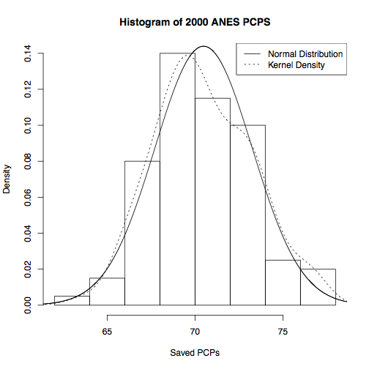

Figure 3: A comparison of the PCPs between theoretically specified models. By comparison to the PCP in the histogram, the medians here fall well below 70%, suggesting that these models are less capable of predicting whether a person votes, Even Campbell et al. 1960, whose model is still well below the mean percentage of the percent correctly predicted.

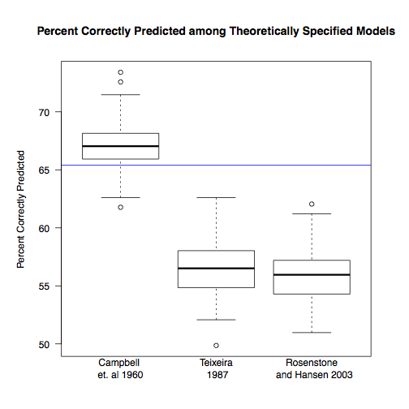

Figure 4: BeSiVa's selections. Out of 100 runs, BeSiVa selected education most often, followed by party ID and time spent in someone's house.

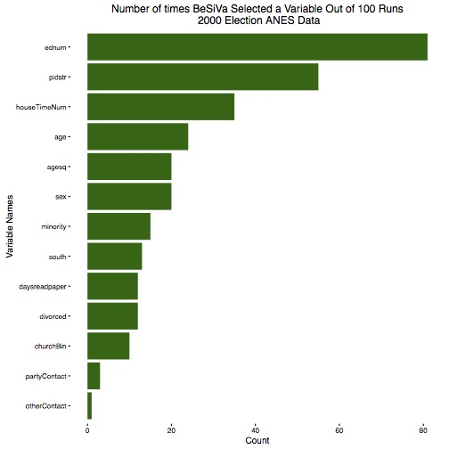

Figure 5: A test of the independent variables. The independent variables selected by BeSiVa in figure 3 were added to models one at a time, and cross-validated 100 times. In this case, the best model is the one that has 7 variables included, but the variation is large.

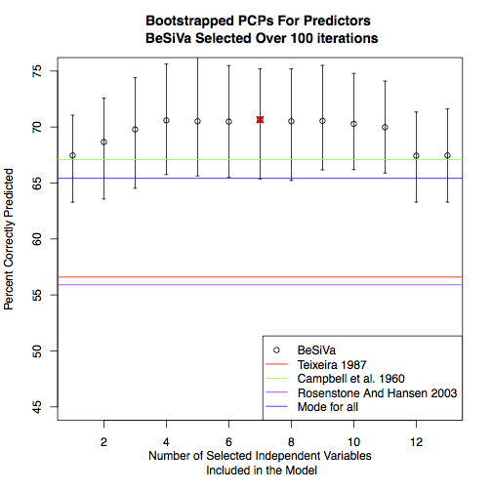

Figure 6: the same test, repeated 1000 times. Note that in this case, the largest PCP is also the first one whose 95% confidence band fall outside the choosing the mode for category, with the first 4 independent variables.

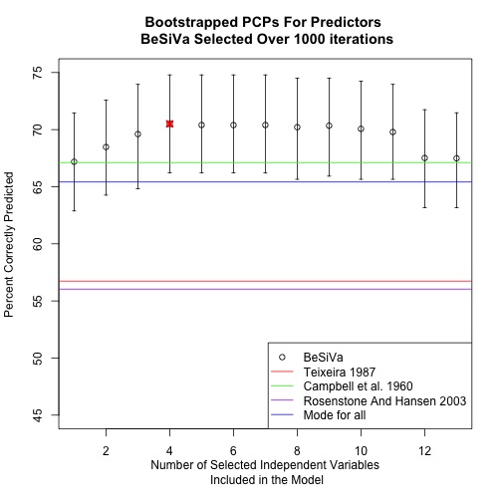

. While the histogram bore marked similarities to a normal distribution, the bounded nature of the data makes the conventional means of plotting confidence intervals problematic, due to the central limit theorem's lack of applicability to bounded distributions.
. While such a conclusion validates a hypothesis mentioned by Teixeira (1987), the variable meant to operationalize mobility in this case may also captures more about the individual than anticipated. Given the lack of class-based variables in the algorithm's selections, despite the inclusion of income in the list of potential independent variables, the length of time a person spends in a single house may be capturing elements of economic class and age. Given its number of selections, time spent in the same house may also be capturing elements of these two independent variables, among others, better than the variables meant to operationalize them it may be that hypotheses about time spent in a location are underrated, it may also be that this variable is highly correlated with other theoretically relevant predictors. The correlations between the amount of time living in one's house and age is slight, it is significant, as signified by their 0.18 pearson's R, which was also the case between time spent in a house and income for a value of 0.14. The correlations between these predictors make sense; a stable place to live, while not necessary, assists with the stability needed to attain a substantial income, and time spent in house necessarily correlates with age. The older an individual is, the longer they can spend living in one place, making age necessary, if not sufficient, to stay in one place for some time. The correlation of these two predictors with the amount of time spent in one's house suggests that it is picking up more information than the question's formulation might expect.
. In addition to determining the average, however, the confidence bands were desired, despite the difficulty of getting a confidence band for a bounded value like the PCP, which ranges between zero and one . For this reason, the confidence bands were determined through bootstrapping; the 2.5th and 97.5th percentiles of the PCPs captured by the cross-validation were measured, creating a bootstrapped 95% confidence band akin to those created for continuous variables

